Topic: Personal and Private Information Online
When I am done this lesson, I will know:
- The difference between personal and private information
- What identity theft is

Pre and Post Self-Assessment
 | Pre | Pre | Post | Post
 | Yes, I know this | No, I want to learn this | Yes, I know this | I still need more practice to learn this
I know what personal information is (online)
I know what private information is (online)
I know what identity theft is


New Words and Terms
sign-up or register
pop-up
personal information
private information
identity theft or fraud

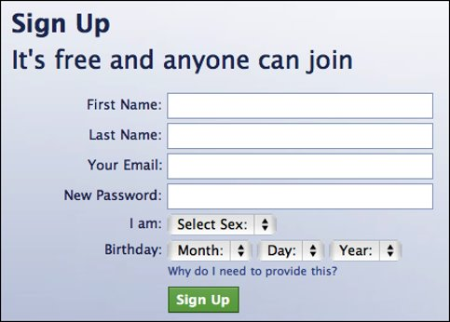
The Internet and devices that connect to the Internet can be very useful and can also be fun to use. Many tools and sites you use on the Internet require you to “sign up” or register. It’s important that you understand the information you are giving and how it can be used. Here is an example of a “sign up” pop-up you might see on an Internet site.

Discussion QuestionS
- Can you think of any examples or websites where you might need to register in order to participate?

- Can you give any examples of types of information you think it would be okay to share online?

Personal and Private Information Online
Personal Information is information that usually can’t be used to identify you on its own. Your personal information tells people things like who you are, where you are, and what you like. Some examples:
- Age
- Gender
Favourite things
This information is usually safe to share online. However, it can be used in combination with private information to help someone identify you.
Private information is information that can be used to identify you. Some examples:
- Social Insurance number (SIN)
- Address
- Phone number
- Email address
Credit card information
 | Watch this video to learn more about the difference between personal and private information.  Source: j potkidis | https://www.youtube.com/watch?v=i7ovB72YXPc

Even though personal information is usually safe to share online, you still need to be very careful with how much personal information you share online. Watch the short video below to see how much information could easily be found on your Facebook page.
 | Watch this video to learn more about how easy it is for someone to find out personal information about you.  Source: Action Fraud UK Police | https://www.youtube.com/watch?v=yrjT8m0hcKU
Information | Personal | Private
Your favourite food | 
Your date of birth
Your opinion
Your first name
Your social insurance number
Your cell phone number
The name of your first pet
Your child’s full name
Your credit card number
Your passport number
How many brothers and sisters you have
Discussion QuestionS
Why would someone want information about me?

Identity Theft
Identity theft or identity fraud is a crime where someone uses your information to pretend to be you or to steal things from you. Once an identity thief has enough information about you, they can use it to do things like buy things on your credit card, post things on your social media account(s) or apply for identification with your name on it like a driver’s license.


Try this/Practice
Look at each type of information and check off if it is personal or private.

When you are registering online or signing up for an account online, you need to think about the information you are sharing so you don’t put yourself at risk! If you aren’t sure whether or not something is safe to be posted online, don’t post it!

Optional: I Want to Learn More
Review this tutorial to learn more about identity theft and how to avoid it.  Source: GCFGlobal.org | https://edu.gcfglobal.org/en/thenow/what-is-identity-theft/1/


Ontario Adult Literacy Curriculum Framework Connection
Competency | Task Group(s)
Find and Use Information | Read Continuous Text (L3)  Interpret Documents (L2- tables and watch video)  Extract Information from Films, Broadcasts and Presentations
Communicate Ideas and Information | Interact with Others (L1- relates past experience)  Complete and Create Documents (L2 – tables)

